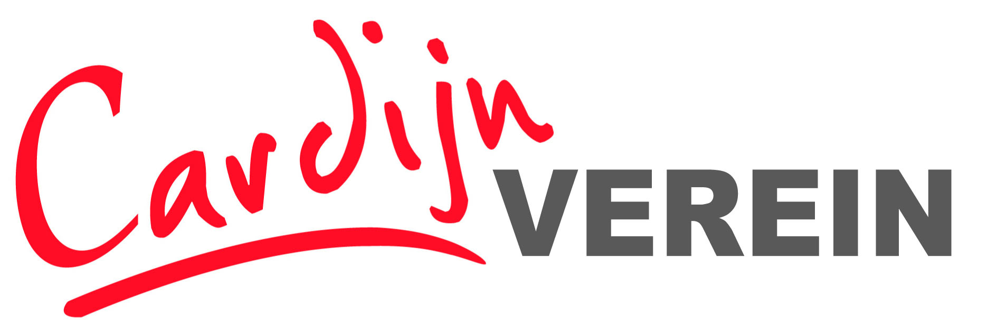
Registration Form – International Seminar

Political Theology Seminar:
‘living together’
Criticism & alternatives to the division of society
Cardijn Haus, Kapuzinerstr. 49, A4020 Linz, Austria
Thursday 23rd April 17.00 until Saturday 25th April at 17.00

Please complete and return this form before 1st April if you are interested to participate!

Return to:
Email: cardijnverein@gmail.com or by post:
Mensch und Arbeit, Kapuzinerstr 84, A4020 Linz, Austria

GIVEN NAME:
FAMILY NAME:
ADDRESS:

ORGANISATION:
(IF APPLICABLE)

TEL:

MOBILE PHONE:
E-MAIL:
WWW:
Other Media:
Working Languages  (X which apply) | English German
SPECIAL REQUIREMENTS
Documents/Diet/ Access/Others

Participation

I will participate in the International Seminar

Time and Date of Arrival

Time and Date of Departure

Fees
Seminar Fee: €50,00

All Meals: Approximately €40,00

Accommodation – Please Book Your Own Accommodation
Here are some suggestions:

Youth Hostel
www.oejhv.at/en/youth-hostels/upper-austria/linz/
Kolping Haus
www.hotel-kolping.at
Star Inn
starinnhotels.com/en/star-inn-hotel-linz-promenadengalerien-by-comfort/
ibis
https://all.accor.com/hotel/1722/index.en.shtml#origin=ibis
Motel One
www.motel-one.com/en/hotels/linz/hotel-linz-hauptplatz/
Lokomotiv
www.hotel-lokomotive.at/?k=1199&agid=3956132259&kw=photel%20linz&creativeid=198881263089&pos=1t2&gclid=EAIaIQobChMI1fShtLG95gIVR-h3Ch3JzAgJEAAYAiAAEgJJoPD_BwE

Please Note:
Travel
- The Cardijn Haus is easily reached from Linz city centre on foot or a couple of stops by bus.
- There is an airport at Linz but there are more and usually cheaper flights to Vienna Airport; From Linz airport there is a bus to the city and from Vienna Airport there is a train to Linz approximately every 30 minutes and it takes about 75 – 90 minutes.
- Detailed travel information will be sent when you register.

Language
Interpretation German – English will be provided in plenaries and some workgroups
Programme
The programme will be finalised by the end of January 2020
- For any urgent questions about the programme or logistics please call:
+43 6605736161

