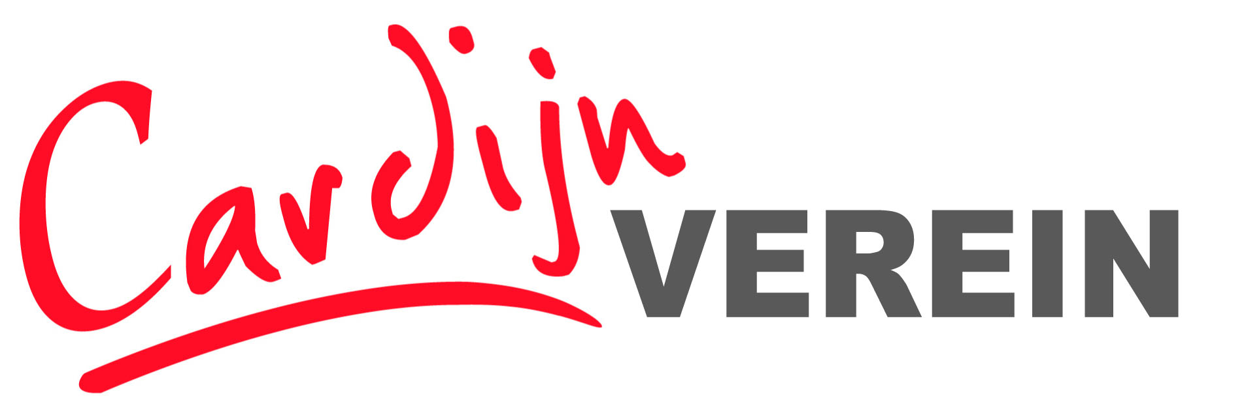
Registration Form – International Seminar
Debt(s) – Forgiveness - Liberation
Debt as a weapon of death - theology for life?

Linz, Austria, Cardijn Haus,
22nd to 25th January 2015
Please complete and return this form if you are interested to participate! The Seminar will start with the evening meal on Thursday 22st January at 18.00 and departures will be after breakfast on 25th January after breakfast
Return to Renate Moser
Email: renate.moser@dioezese-linz.at - or by post:
Renate Moser, mensch & arbeit, Kapuzinerstr 84, A4020 Linz, Austria
More information: www.cardijn-verein.org or from Tony Addy, Email: tony@pro-vocation.org
GIVEN NAME:

FAMILY NAME:
ADDRESS:

ORGANISATION:
(IF APPLICABLE)

TEL:

MOBILE PHONE:
E-MAIL:
WWW
Other Media:
SPECIAL REQUIREMENTS
Documents/Diet/ Access/Others

I apply for financial support for the accommodation costs (please give the reason)

